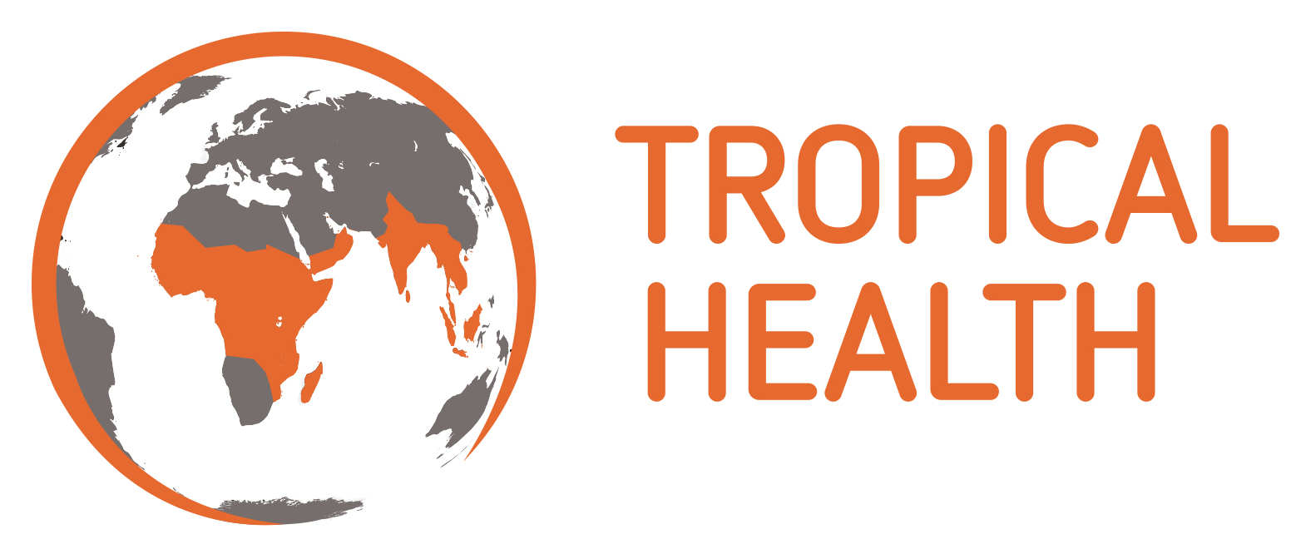

Terms of Reference
New Nets Project in Mozambique – Observational impact analysis to evaluate evidence from piloted new net distributions – qualitative study

Role title: 2 roles include 1 x National Consultant (Lead) and 1 x Consultant (Research Assistant)
Contract type: Short-term consultants x 2 –up to 2 months duration each
Period: August 2021 – September 2021
Location: Mozambique with field visits across the project area
Level of Effort: TBC
Reporting: Technical Director – Hannah Koenker

Background
As part of the New Nets Project initiative to catalyze the market introduction of next-generation insecticide treated bed nets (ITNs), several countries that are piloting the deployment of next-generation nets have been selected for enhanced surveillance activities to support observational impact analyses. In these countries, epidemiological, entomological, and qualitative data will be collected to evaluate the public health impact of deploying next-generation nets in terms of entomological, epidemiological, cost-effectiveness, and other relevant outcomes. In Mozambique, pilot implementation studies will occur in two different regions of the country – one evaluation in the northern provinces of Zambezia and Niassa and one evaluation in the western provinces of Tete, Manica, and Sofala.

In both pilot study locations, the National Malaria Control Program (NMCP) implemented mass distribution of different types of mosquito nets as part of a universal coverage campaign in August 2020, and surveillance activities occurred in three neighboring districts with similar malaria transmission dynamics in each location. In the north, Gurué District distributed standard (pyrethroid-only) ITNs, Cuamba District distributed Interceptor G2® (IG2) ITNs, and Mandimba District distributed Royal Guard® (RG) ITNs. In the west, Chemba District distributed standard ITNs, Guro District distributed IG2 ITNs, and Changara District distributed PBO ITNs.

Qualitative Study Objective:
Gathering evidence on ITN uptake and usage is crucial to understanding the social determinants of impact for next-generation nets and determining transmission risk defined as the intersection between time at risk of mosquito blood feeding and human activities not taking place under protection of an ITN. The collection of reliable data on such patterns is therefore an essential component of the evaluation of the next-generation pilots for both modeling and contextual analysis of impact. As such, the human behavior component of the evaluation will explore the reception of next-generation ITNs within the population of the selected study districts. The Lead Consultant will work directly with Tropical Health Technical Director to lead the implementation of the qualitative components of the study in each study district.

Table 1. Summary of activities by study location
 | Districts
 | Cuamba | Mandimba | Guro | Changara
Qualitative
Direct observations of human behavior | x | x | x | x
Focus group discussions | x | x | x | x

Methods
This activity will employ a mixed-method approach. The qualitative component will investigate the human behaviours that influence patterns of exposure, providing a crucial framework of analysis to the quantitative data. The quantitative component will measure the actual time individuals spend in and out of the protection of ITNs, including classifications of types of activities and locations. This information will aid in the modeling and cross-analysis with entomological and epidemiological data.

Team
The technical oversight will be supported by the Tropical Health Technical Director, the Mozambique Senior Project Coordinator, and supported by two Mozambican Consultants namely a Team Lead (TL) and a Research Assistant (RA), who will be responsible for

      - training and supervising data collectors in the study districts,
- ensuring that observations are appropriately coded and themes identified for subsequent focus group discussions.
- The Lead Consultant will also be responsible for routine check-ins with Technical Director for updates and idea exchange.

Tropical Health will assist in the recruitment of 2 local FGD facilitators per district. These facilitators will assist the TL and the RA during the fieldwork in their respective districts. The TL and RA will be responsible for
- setting schedules
- securing informed consent
- maintaining community relationships
- supporting night-time observations and FGDs
- Timely transmission of data (TL and RA must have their own laptops)
- Initial analysis of data
- Participation in subsequent scientific articles developed from the qualitative data

Approach
We anticipate total fieldwork to be completed in approximately 30 days. The TL and the RA would jointly conduct 2-day trainings of 4 FGD facilitators each at NNP project offices in Gurue, and then again in Tete. FGD facilitators would be local to the relevant district, speak the local language(s), and be able to facilitate discussions and/or take notes. The TL and RA will then lead their respective teams through fieldwork in Cuamba and Mandimba, then Changara and Guro, beginning with night-time observations, followed by FGDs. In each district, four sites will be identified, consisting of 2 locations (Site 1 and Site 2) that have a peri-urban and a rural setting (see Tables 1 and 2). Within a given district, the two sites would ideally be in somewhat different areas, for example one site in the southern parts of Changara and Guro around the district capitals, the second sites in the northern parts of each district, near the Zambezi River. Within a given site, the peri-urban and rural settings should be located within 10-15km of each other.

Night-time observations
In each site, four local community members will be identified who are willing to conduct night-time observations of net use at their (own) households. The TL or RA will provide a brief training and orientation to the volunteers. The night-time observations will include observations and recordings of waking times, evening activities around the home, and sleeping times (including broad observations of time spent in and out of ITNs). A structured paper observational tool will guide the data collection. Volunteers will be visited in the early evening to check data quality and answer any questions. Completed forms would be picked up the following morning by the TL or RA, and a small stipend provided to the volunteer. A total of 3-4 households x 4 sites x 4 districts will be recruited for night-time observations, providing data from multiple households prior to conducting FGD in each site. The TL/RA will enter data from the paper forms into an Excel database. A day is allotted for review of observation data prior to beginning FGDs.

Table 1: Number of Night-time Observations per location
District Lead | TL | RA | TL | RA
 | Cuamba | Mandimba | Changara | Guro | Total Night-time Observations
Site 1 Urban | 4 hh | 4 hh | 4 hh | 4 hh | 16
Site 1 Rural | 4 hh | 4 hh | 4 hh | 4 hh | 16
Site 2 Urban | 4 hh | 4 hh | 4 hh | 4 hh | 16
Site 2 Rural | 4 hh | 4 hh | 4 hh | 4 hh | 16
Total | 16 | 16 | 16 | 16 | 64 hh

Focus group discussions (FGDs):
After observations have been completed, key themes will be extracted and focus group discussions held with determined homogenous groups to explore factors in transmission risk, especially those associated with specific ITN usage. These will be conducted using semi-structured guides and validation of theories developed through the analysis of observations and key informant interviews. FGDs would include a mix of 8-10 male and female participants (adults 18 or older) who received ITNs in the recent campaign. Those wishing to participate will be enrolled and written consent will be obtained.

Participant inclusion criteria for key informant interviews, focus group discussions, and participant observation:
- Individuals of both sexes, not belonging to vulnerable categories (those with cognitive impairment or any other person for whom full and open consent cannot be guaranteed), and above the age of 18.

The study team will plan to conduct 2 FGDs per day, generally in the morning, leaving time to write up notes and transcripts each afternoon/evening.

Table 2: Number of Focus Group Discussions (FGD) per location
District Lead | TL | RA | TL | RA
 | Cuamba | Mandimba | Changara | Guro | Total FGDs
Site 1 Urban | 2 | 2 | 2 | 2 | 8
Site 1 Rural | 2 | 2 | 2 | 2 | 8
Site 2 Urban | 2 | 2 | 2 | 2 | 8
Site 2 Rural | 2 | 2 | 2 | 2 | 8
Total | 8 | 8 | 8 | 8 | 24

Specific detailed requirements for each role

Job Summary/Responsibilities (covers both roles):
- Actively participate in the finalization of all data collection tools including night-time observations of households and FGD guides
- Develop framework for the recruitment of night-time observers and FGD facilitators
- In conjunction with the principals, produce training manuals and conduct training of all facilitators and observers recruited
- Produce coding sheets ahead of field work/collection of data
- Communicate promptly with Tropical Health Mozambique team in case of challenges or issues
- Be responsible for field coordination activities and ensure that facilitators and observers conduct themselves professionally while in the field.
- Analyze all FGDs using appropriate qualitative data analysis tool e.g. Atlas.ti, Nvivo, or similar.
- Responsible for timely production of fieldwork report for review
- Responsible for timely production of draft analysis report

Qualifications / Experience – Team Leader
- PhD in Anthropology or Sociology or PhD student in Anthropology or Sociology (towards the end of their study)
- Minimum of 5 years working in sociocultural anthropology, which researches on customs and behavioral aspects of a given group
- Documented evidence on training experience and research abilities
- Speaks Portuguese fluently and a good standard of spoken and written English
- Vast knowledge of working in Mozambique and having spent time delivering fieldwork and understands the local cultures
- Ability to work and supervise research assistants/teams doing research activities in the field
- Ability to work under pressure and meet deadlines.
- Excellent report writing skills
- Computer literate in the use of basic standard software such as Microsoft Office.
- Proficient in the use of Atlas.ti and/or Nvivo or similar

Qualifications / Experience – Research Assistant
- PhD student in Anthropology or Sociology
- Minimum of 3 years working in sociocultural anthropology, which researches on customs and behavioral aspects of a given group
- Proficiency in training and research abilities
- Speaks English and Portuguese fluently
- Good experience and knowledge working in Mozambique and have spent time in fieldwork and understands local culture
- Ability to work with data collectors doing research activities in the field
- Ability to work under pressure and meet deadlines.
- Report writing skills
- Computer literate in the use of basic standard software such as Microsoft Office.
- Proficient in the use of Atlas.ti and/or Nvivo or similar

Tentative Timeline and Deliverables

Table 2. Tentative Timeline

Table 3: Summary of Anthropological fieldwork
 | ALC+2 | PHD-A+2 |  | ALC+2 | PHD-A+2
 | Cuamba | Mandimba |  | Changara | Guro
Day 0 | Travel to Gurue | Travel to Gurue
Day 1 | FGD Training in Gurue NNP Office
Day 2
Day 3 | Community Mobilization | Community Mobilization
Day 4 | S1U Obs | S1U Obs
Day 5 | S1R Obs | S1R Obs
Day 6 | S2U Obs | S2U Obs
Day 7 | S2R Obs | S2R Obs
Day 8 | Data review | Data review
Day 9 | S1U x 2 | S1U x 2
Day 10 | S1R x 2 | S1R x 2
Day 11 | S2U x 2 | S2U x 2
Day 12 | S2R x 2 | S2R x 2
Day 13 | ALC travel to Tete | PhD-A travel to Tete
Day 14 |  |  |  | FGD Training in Tete NNP Office | FGD Training in Tete NNP Office
Day 15 |  |  |  | FGD Training in Tete NNP Office | FGD Training in Tete NNP Office
Day 16 |  |  |  | Community Mobilization | Community Mobilization
Day 17 |  |  |  | S1U Obs | S1U Obs
Day 20 |  |  |  | S1R Obs | S1R Obs
Day 21 |  |  |  | S2U Obs | S2U Obs
Day 22 |  |  |  | S2R Obs | S2R Obs
Day 23 |  |  |  | Data review | Data Review
Day 24 |  |  |  | S1U x 2 | S1U x 2
Day 25 |  |  |  | S1R x 2 | S1R x 2
Day 26 |  |  |  | S2U x 2 | S2U x 2
Day 27 |  |  |  | S2R x 2 | S2R x 2
Day 28 |  |  |  | ALC travel to Maputo | PhD-A travel to Maputo

Key activities | Date | Responsible Party
Conduct data collection (including training of personnel, fieldwork, and reporting) | August – September 2021 | Lead Consultant and TH
Submission of data | August – September 2021 | Lead Consultant
Fieldwork report | August - September 2021 | Lead Consultant

Expected deliverables include:
- Feedback on selection criteria for FGD facilitators and household observers
- Data collection and processing strategy outlined (i.e. transcripts, coding and storage)
- Excel database of night-time observation data (template will be provided)
- Transcripts and notes from FGDs
- Fieldwork report

The TL and RA will be included in the development of manuscripts arising from the data collected.

Application details
For more details on how to apply, please go to the ‘Work with us’ section of our website at https://www.trophealth.com/work-with-us/
Application deadline is 9th August 2021 at 17:00hrs GMT (19h00 Mozambique)
Only shortlisted candidates will be contacted.

